Observation Capture
The purpose of the Observation Capture is to capture a supervised observation of a trainee’s work-based performance linked to the learning goals.

Workflow
Trainee
Request an Observation Capture from an assessor. This can be the rotation supervisor or another assessor including an Advanced Trainee, a nurse or other healthcare professional.
Set up the observation activity, including location, activity etc.
Complete the personal and assessment information section of the form.
Assessor
Observe the Trainee doing a work-based activity.
Complete the Observation Capture form.
Send the Observation Capture to the trainee for reflection.
Trainee
Review the Observation Capture completed by the Assessor.
Complete the reflection
Save a copy of the Observation Capture for your records.
Send the saved completed Observation Capture to curriculum@racp.edu.au
RACP staff
Save and upload documentation to Tracc when available.

Please note that this form is for use at settings that have nominated to use electronic assessment forms in place of Tracc for a period of time. For a list of settings using these forms, including timeframes, please see the new Basic Training program webpage.
If your setting has not elected to use electronic forms, please use Tracc to complete your assessments.
If you have any questions or require additional support using this form, please contact the Basic Training Curricula Renewal team at curriculum@racp.edu.au

Trainee name and MIN  Title, preferred name, surname, MIN  Click or tap here to enter text. | Training information include rotation name, date to date, specialty, setting location  Click or tap here to enter text.
Date of Observation Capture  Click or tap to enter a date. | Assessor Title, Preferred name, last name Click or tap here to enter text.  Email Click or tap here to enter text.  Role Click or tap here to enter text.
Summary of activities | Click or tap here to enter text.
Setting of activity  If you choose ‘other’, please describe this in the text box. | Choose an item.  Click or tap here to enter text.
Assessor Feedback
Select the primary learning goal that is the focus of your observation  See Appendix 1 for details | ☐ Clinical assessment  ☐ Communication with patients  ☐ Documentation  ☐ Prescribing  ☐ Transfer of care | ☐ Investigations  ☐ Acutely unwell patients  ☐ Procedures  ☐ Knowledge  ☐ Professional behaviours |  | Optional: list the components of the learning goal that you observed (see descriptors in appendix 1)  Click or tap here to enter text.
Complexity of case | Choose an item.
How much supervision did the trainee require during this activity? | Choose an item.
What did the Trainee do well? | Click or tap here to enter text.
What could the Trainee do next time to improve their performance? | Click or tap here to enter text.
Trainee reflection
What do you think you did well? | Click or tap here to enter text.
What could you do to improve next time? | Click or tap here to enter text.
(Optional) Select the secondary learning goal(s) to which this assessment applies  See Appendix 1 for details | ☐ Clinical assessment  ☐ Communication with patients  ☐ Documentation  ☐ Prescribing  ☐ Transfer of care |  | ☐ Investigations  ☐ Acutely unwell patients  ☐ Procedures  ☐ Knowledge  ☐ Professional behaviours

Appendix 1 – Learning Goal Descriptors
Refer to the New Basic Training Curricula Standards for full details of the expected standard for each learning goal.
Clinical assessment
Clinically assess patients, incorporating interview, examination, and formulation of a differential diagnosis and management plan
This activity requires the ability to:
- obtain histories
- examine patients
- integrate information from assessments into comprehensive formulations
- develop provisional and differential diagnoses and problem lists
- discuss findings with patients, families, or carers¹
- present findings to colleagues, including senior clinicians
- perform this activity in multiple settings, including inpatient and ambulatory care settings and in emergency departments.

Communication with patients
Discuss diagnoses and management plans with patients and their families or carers
This activity requires the ability to:
- communicate with patients and their families or carers from a broad range of socioeconomic and cultural backgrounds
- communicate with colleagues and other staff
- use of different modalities for communication, such as face-to-face, email, or phone calls
- perform this activity in multiple settings, including inpatient and ambulatory care settings and in emergency departments.

Documentation
Document the progress of patients in multiple settings
This activity requires the ability to:
- produce written summaries of care, including discharge summaries, clinic letters, and transfer documentation
- provide information for colleagues, health professionals, and patients
- prepare written correspondence that functions as a historical record of patients’ presentation, management and progress, including key points of diagnosis and decision making, and as a clinical handover tool to inform follow-up and coordination of care plans
- produce clinical documentation that summarises current issues and enables subsequent health professionals to understand the issues and continue care
- perform this activity in multiple settings, including inpatient and ambulatory care settings and in emergency departments.

Prescribing
Prescribe medications tailored to patients’ needs and conditions
This activity requires the ability to:
- take and interpret medication histories
- choose appropriate medications* [Includes drugs, fluids, and oxygen.]
- communicate with patients about the benefits and risks to patients, and provide instruction on medication administration effects and side effects
- produce prescriptions
- monitor medications for efficacy, safety, and concordance
- review medications and interactions, and cease where appropriate
- perform this activity in multiple settings, including inpatient and ambulatory care settings and in emergency departments
Transfer of care
Transfer care of patients
This activity requires the ability to:
- transfer care at any transition point, including:
  - at admission
  - between clinical services
  - at changes of shift
  - at discharge to ambulatory and community care
- ensure continuation of care
- share patient information with other health care providers in conjunction with the transfer of responsibility for patient care
- select modes of information transfer, such as oral and written format
- communicate (at least):
  - patient demographics
  - concise medical history
  - current problems and issues
  - details of pertinent and pending investigation results
  - medical and multidisciplinary care plans
  - upcoming possibilities
- perform this activity in multiple settings, including inpatient and ambulatory care settings and in emergency departments
Investigations
Choose, organise, and interpret investigations
This activity requires the ability to:
- plan, rationalise, and arrange investigations
- discuss investigative plans with patients, their families, or carers, and support them to make informed choices
- follow-up the results of investigations and interpret the results independently
- follow-up investigations that have been ordered but not performed
- communicate results of investigations with patients
- modify management plans based on new information
- perform this activity in multiple settings, including inpatient and ambulatory care settings and in emergency departments.
Acutely unwell patients
Assess and manage acutely unwell patients
This activity requires the ability to:
- assess seriously unwell or injured patients and initiate management, including mobilising available resources
- recognise clinical deterioration and respond by following the local process for escalation of care
- recognise and manage acutely unwell patients who require resuscitation
- lead the resuscitation team initially, and involve other necessary services, such as intensive care or retrieval services
- perform this activity primarily in inpatient settings

Procedures
Plan, prepare for, perform, and provide after care for important procedures
This activity requires the ability to:
- select procedures
- work in partnership with patients and their families or carers to make choices that are right for them, including obtaining consent
- set up the equipment, maintaining a sterile field
- perform procedures
- provide after care for patients, and communicate after-care protocols and instructions to patients and medical and nursing staff
- perform this activity in multiple settings, including inpatient and ambulatory care settings and in emergency departments.
This activity does not include complex procedures that require specialist training or are inappropriate for Basic Trainees.

Professional behaviours
Behave in accordance with the expected professional behaviours, values, and practices
This requires meeting the competencies expected of Basic Trainees in the ten RACP domains of professional practice, which are summarised as the following Professional Standards.
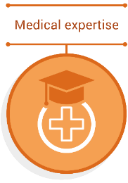 | Physicians apply knowledge and skills informed by best available current evidence in the delivery of high-quality, safe practice to facilitate agreed health outcomes for individual patients and populations.
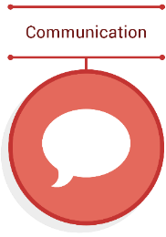 | Physicians collate information, and share this information clearly, accurately, respectfully, responsibly, empathetically and in a manner that is understandable.  Physicians share information responsibly with patients, families, carers, colleagues, community groups, the public, and other stakeholders to facilitate optimal health outcomes.
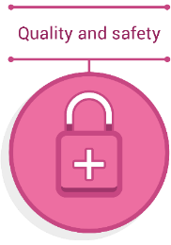 | Physicians practice in a safe, high-quality manner within the limits of their expertise. Physicians regularly review and evaluate their own practice alongside peers and best practice standards and conduct continuous improvement activities.
Physicians demonstrate a lifelong commitment to excellence in practice through continuous learning and evaluating evidence. Physicians foster the learning of others in their profession through a commitment to mentoring, supervising, and teaching.*
*Adapted from Richardson D, Oswald A, Chan M-K, Lang ES, Harvey BJ. Scholar. In: Frank JR, Snell L, Sherbino J, editors. The Draft CanMEDS 2015 Physician Competency Framework – Series IV. Ottawa: The Royal College of Physicians and Surgeons of Canada; 2015 March.
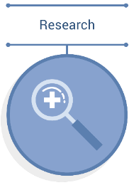 | Physicians support creation, dissemination and translation of knowledge and practices applicable to health.* They do this by engaging with and critically appraising research and applying it in policy and practice to improve the health outcomes of patients and populations.
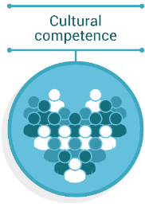 | Physicians engage in iterative and critical self-reflection of their own cultural identity, power, biases, prejudices and practising behaviours. Self-reflection and an understanding the cultural rights of the community a physician serves brings awareness and accountability for the impact of their own culture on decision-making and healthcare delivery. It also allows for an adaptive practice where power is shared between patients, family, whānau and/or community and the physician, to improve health outcomes.  Physicians recognise the patient and population’s rights for culturally safe care, including being an ally for patient, family, whānau and/or community autonomy and agency over their decision-making. This shift in the physician's perspective fosters collaborative and engaged therapeutic relationships, allows for strength-based (or mana-enhanced) decisions, and sharing of power with the recipient of the care to optimise health care outcomes.  Physicians critically analyse their environment to understand how colonialism, systemic racism, social determinants of health and other sources of inequity have and continue to underpin the healthcare context. Consequently, physicians then can recognise their interfacing with, and contribution to, the environment in which they work to advocate for safe, more equitable and decolonised services and create an inclusive and safe workplace for all colleagues and team members of all cultural backgrounds.  Definition of cultural safety  The RACP has adopted the Medical Council of New Zealand's definition of cultural safety (below):  "Cultural safety can be defined as¹:  - The need for doctors to examine themselves and the potential impact of their own culture on clinical interactions and healthcare service delivery.  - The commitment by individual doctors to acknowledge and address any of their own biases, attitudes, assumptions, stereotypes, prejudices, structures, and characteristics that may affect the quality of care provided.  - The awareness that cultural safety encompasses a critical consciousness where healthcare professionals and healthcare organisations engage in ongoing self-reflection and self-awareness and hold themselves accountable for providing culturally safe care, as defined by the patient and their communities."  ¹Curtis et al. “Why cultural safety rather than cultural competency is required to achieve health equity”. International Journal for Equity in Health (2019) 18:174
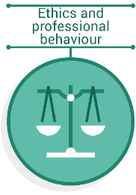 | Physicians' practice is founded upon ethics, and physicians always treat patients and their families in a caring and respectful manner. Physicians demonstrate their commitment and accountability to the health and well-being of individual patients, communities, populations and society through ethical practice.  Physicians demonstrate high standards of personal behaviour.
 | Physicians collect and interpret information, and evaluate and synthesise evidence, to make the best possible decisions in their practice. Physicians negotiate, implement, and review their decisions and recommendations with patients, their families and carers, and other healthcare professionals.
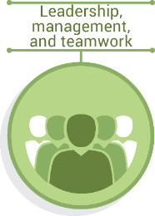 | Physicians recognise, respect, and aim to develop the skills of others, and engage collaboratively to achieve optimal outcomes for patients and populations.  Physicians contribute to and make decisions about policy, protocols, and resource allocation at personal, professional, organisational, and societal levels.  Physicians work effectively in diverse multidisciplinary teams and promote a safe, productive, and respectful work environment that is free from discrimination, bullying, and harassment.
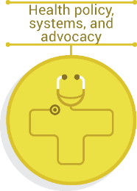 | Physicians apply their knowledge of the nature and attributes of local, national, and global health systems to their own practices. They identify, evaluate, and influence health determinants through local, national, and international policy. Physicians deliver and advocate for the best health outcomes for all patients and populations.

Knowledge
Acquire the baseline level of knowledge for Basic Training
This requires understanding of the following important topics and concepts relating to a range of medical specialties:
- key presentations and conditions
- less common or more complex presentations and conditions
- epidemiology, pathophysiology and clinical sciences
- investigations, procedures and clinical assessment tools
- important specific issues.

Adult Internal Medicine | Paediatrics & Child Health
Cardiology | Adolescent and Young Adult Medicine
Dermatology | Cardiology
Endocrinology | Clinical Sciences
Gastroenterology | Dermatology
General Medicine | Emergency Medicine
Genetic and Metabolic Medicine | Endocrinology
Geriatric Medicine | Gastroenterology
Haematology | General and Community Paediatrics
Immunology and Allergy | Genetic and Metabolic Medicine
Infectious Diseases | Haematology and Oncology
Medical Obstetrics | Immunology and Allergy
Medical Oncology | Infectious Diseases
Nephrology | Neonatal and Perinatal Medicine
Neurology | Nephrology and Urology
Palliative Medicine | Neurology
Pharmacology, Toxicology and Addiction Medicine | Respiratory and Sleep Medicine
Respiratory and Sleep Medicine | Rheumatology
Rheumatology

