Potential Breach Form
This form outlines when a potential breach has occurred.

Potential Breach Overview
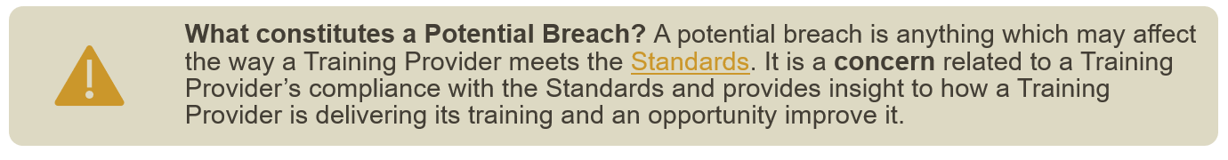
Training Providers who do not notify the RACP of a change of circumstance in a timely manner may also risk breaching the Standards.

A breach may include but is not limited to:
- bullying and harassment,
- discrimination,
- changes to supervision that may affect training,
- rostering changes that may affect training opportunities
- any incident or circumstance which could impact the Training Provider’s integrity or capacity to deliver service and/or Training Programs.
- concerning responses from surveys
- media articles

How to complete this form

To complete this form, RACP staff or the notifier need to:
- Read the Managing a Potential Breach process
- Complete the Managing a Potential Breach form (this document)
- Submit this form to the Training Accreditation Services at the email address below.

Aotearoa New Zealand | Australia
Email:  Training Accreditation Services AoNZ  Call:  0508 697 227 (+64 4 472 6713)  9am to 5pm, Monday to Friday | Email:  Training Accreditation Services AU:  Call:  1300 697 227 (+61 2 9256 5444)  8:30am to 5:30pm, Monday to Friday
If you need assistance completing the form, please contact the Training Accreditation Services via the details above.

TRAINING PROVIDER DETAILS

Setting name
Address
Training Network name
(If applicable)

Training Program |  | (Please select one.)
NOTIFIERS CONTACT DETAILS (Confidential)
This could be anyone that informs of the breach. If it is an organisation, please fill in as much detail as possible.

Name
Position title
Email
Phone

I consent to my identity being disclosed as part of this process | Yes | No

DETAILS OF THE POTENTIAL BREACH

DESCRIPTION OF BREACH
Please describe the potential breach and any impact it can have on training. Please also add any supporting documentation if required.

Appendix 1

Consequence

Conditions and recommendations are classified by the impact and consequence of the issue on the quality of training, patient safety and trainee and/or educator wellbeing. The RACP classifies issues as minor, moderate and major consequence. The action taken by the RACP is determined by these classifications.
Minor consequence
An issue identified which has low impact on the quality of training, Training Program, and training system in place at a Setting or Training Network.
Accreditors and the relevant committee will be notified of any issues of minor consequence at each committee meeting, and it may be considered at the time of the next accreditation review. The recommended review timeframe for a minor consequence is at the next comprehensive review (i.e., 4 years). It is typical for a recommendation to be a minor impact on training or safety.
Moderate consequence
An issue identified which has a substantial impact on the working conditions of trainees and/or educators and possibly on the training provided. This issue may impact patient safety and/or trainee and educator safety or wellbeing.
The issue can result in a condition or recommendation being placed on a Training Program, Setting, or Training Network. The recommended review timeframe for a moderate consequence is within 12 months.
Major consequence
An issue identified which has a serious impact on training, patient safety and/or trainee and educator safety or wellbeing. The issue can result in an immediate focus review or modification of a Training Program, Setting, and Training Network accreditation status.
The recommended review timeframe for a major consequence is within 3 months.

RACP STAFF ONLY
LEVEL OF CONSEQUENCE
Based on the consequence descriptions in the potential Breach process, identify the level of consequence from the change.

Minor Consequence

Moderate Consequence

Major Consequence

An Issue can also be a change in circumstance or potential breach of standards. Refer to Change of circumstance and Potential breach for further details.

