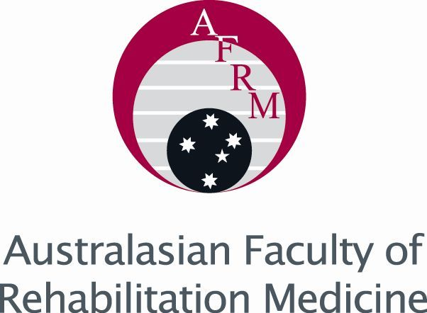
Dr Boris Mak Rehabilitation Medicine Trainee Award for Best Presentation

Application to Present
Name:
Address:
Email:
Mobile phone:……………………………

☐ High resolution photo attached
☐ Brief bio attached
☐ I accept the terms and conditions of this prize

Copy of Presentation must be received by email to: AoNZ_AFRM@racp.org.nz
Closing date: Friday, 5 June 2026

Signed:

