Professional Development Review - Notes

Purpose of the review
The Professional Development Review (PDR) is designed:
- to assist in supporting reflection on your practice
- as a supportive and collegial review of your practice by peers
- where relevant, to meet the bulk of your employer’s requirements for annual performance review
- to assist you to make evidenced based decisions on CPD activities
- to limit the compliance activities you are required to complete
- provide a tool that will attract MyCPD credits in category 2 – Reviewing Performance.
For New Zealand Fellows
- to meet the MCNZ recommendations for regular practice review
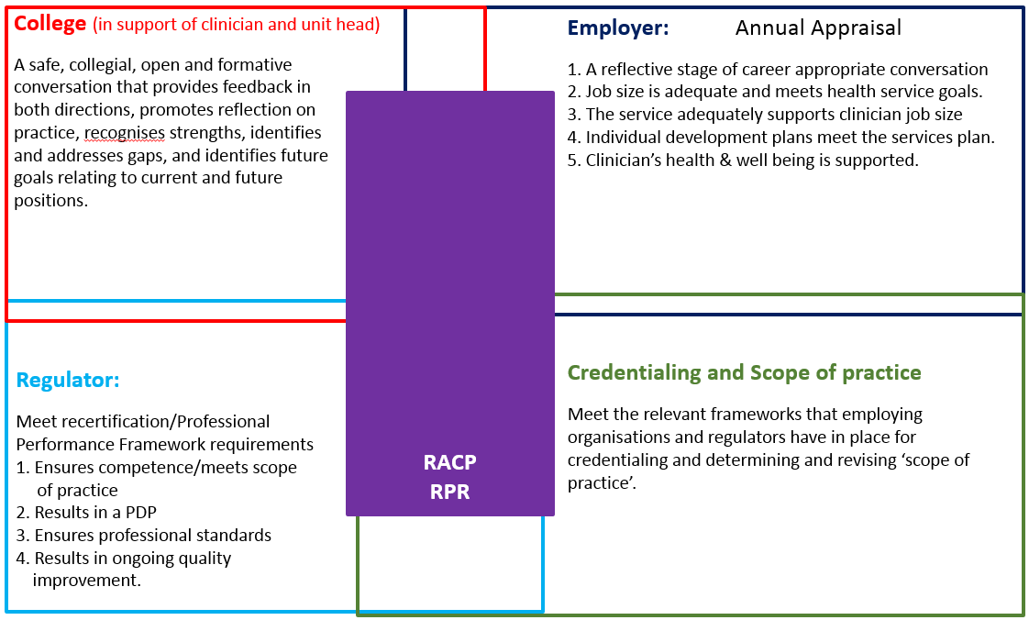
In a PDR you (the reviewee) and (where appropriate) the employing organisation share responsibility for the outcome. Information in Part A will generally remain confidential and in most instances only you will retain a copy of Part A. Information in Part B may be shared with the employing organisation to assist in meeting its compliance requirements.
The PDR is designed to facilitate:
- reflection upon past practice and informed planning for improvement
- feedback from peers that is presented in ways most likely to be effective in improving performance
- personal professional development and workplace improvement, aimed at improving health care outcomes
- early identification of the risk of underperformance
- early identification of underperformance
One aspect of the PDR that sets it apart from other reviews is the focus on the needs of the individual doctor. The focus on self-care and on the candidate’s health and on identifying ways in which the organisation either supports or hinders the doctor in their work reinforces the PDR as a developmental tool designed to assist individuals improve their practice in the context of the organisation they work in.
The PDR forms the first element in the RACP’s framework for Practice Review. The aim of the PDR is to meet the key stakeholder aims and needs.
A key outcome of a PDR is an individual clinician’s updated Professional Development Plan (PDP) – not a score or a rating. You can use the PDP that is part of the form or use the PDP in MyCPD.
If you are not in a clinical role, but one which entails case or file review, this is still a clinical service requiring clinical competence. Similarly, if you are researching or teaching then your review must focus on those areas such as review of research ethics compliance or evidence –informed teaching.
The second element in the RACP Practice Review framework is a Service Development Survey (SDS) that focuses on a review of the broader service.

Structure of the PDR
Part A: | Only you as reviewee will keep this section
Section One: Overview of the Year. | What is going well – what needs to change.  Has cultural competence and health equity been a focus of my practice.
Section Two: Job Satisfaction | Comment on your job satisfaction.
Section Three: Maintaining Your Health. | Reflect on factors pertaining to your own health and wellbeing.
Part B: | This section will be retained and may be used towards completing annual performance review and other compliance requirements
Section Four: Areas of Speciality Practice. | Does your practice support maintenance of your skills.  Is your job size current and relevant?
Section Five: Maintaining skills and competence. | What progress have you made on your Professional Development Plan (PDP) goals?  Record the activities you have undertaken to maintain your skills and competence.
Section Six: Professional Development Plan (PDP). | Use the PDP in MyCPD or the plan in section 6 to note down your future CPD plans
Section Seven: Feedback. | Your reviewers will complete. There is an opportunity for you to provide comments on the process.
Part C:  HR Summary Sheet | This section may be used towards completing annual performance review and other compliance requirements  Completed by manager where required

Notes on completion

Part A
The other core document that will assist in reflecting on your practice is the RACP Professional Practice Framework.
The information in part A will form the basis of an open and collegial conversation reflecting on the period since your last review. This information will remain between you and your reviewers unless anything emerges from the review meeting that is covered by other legislative reporting requirements.
Please note that section 3B. Maintaining your Health and wellbeing is optional
Your health and wellbeing are crucial to your practice. While it is not a requirement to discuss issues of health and wellbeing, the PDR offers an opportunity to do so if you wish – particularly if there are aspects of your job that are impacting on your health and well-being. Areas you might consider discussing are:
- work/life balance (are you taking an appropriate amount of leave / how many hours do you work / do you get sufficient exercise and sleep?)
- managing stress (are you satisfied you have effective strategies in place / does your alcohol meet recommended alcohol intake guidelines?)
If you choose not to discuss these during your PDR meeting please consider raising them with your GP or another appropriate professional.
All Fellows should be aware of the RACP Support Program. There are also resources available in the Doctors’ Health and Wellbeing curated collection and further resources available via the RACP webpage - ‘Supporting a colleague or trainee’.

Part B
The information in part B focuses on reflecting on your clinical and professional activity to identify what further development will be most useful. Depending on your purpose in participating, this information may be shared by you and/or your Head of Department to meet other compliance requirements such as annual review or credentialing. Please print this section separately from Part A so that it can be easily separated. Please note though that you may choose to complete the review outside of any institutional requirements.
One source of information for PART B is the PDP you set following your last PDR meeting. Please include a copy of that PDP when you send the PDR form to your reviewers. This can be the PDP from MyCPD/ the PDP in section 6 of the PDR or a PDP using any format you prefer.
One outcome of Part B is a revised PDP for the coming period – again, using any format you prefer.
Section 5.2 Peer Review
It is a mandatory requirement of the Medical Council of New Zealand (MCNZ) that you participate annually in 10 hours of peer review and it is the intention of the MBA to require a minimum of 12.5 hours of performance review activities as part of CPD. For further information and ideas on peer review please see the audit and peer review ideas for RACP Fellows.
The level of detail you provide on peer review activities will depend on the activities undertaken. If you have completed an MSF a summary of your feedback and agreed action will be useful.
Please see below for details on further activities that can be undertaken as peer review. Please note that if the PDR is being used to meet MCNZ RPR requirements that a Multisource Feedback (MSF) or equivalent is required every three to five years.
Further examples of Peer Review
Peer review is an evaluation of the performance of individuals or groups of doctors by members of the same profession or team. It may be formal or informal and can include any time when doctors are learning about their practice with colleagues. Peer review can also occur in multidisciplinary teams when team members, including other health professionals, give feedback. In formal peer review, peer(s) systematically review aspects of your work, eg. the first six cases seen, or a presentation on a given topic. Peer review normally includes feedback, guidance and critique of your performance.

- Clinical Notes Review
A planned review of your clinical practice by reviewing a minimum of 12 randomly-selected or sequential case notes. Items to consider are legibility of record keeping (written or in a letter), evidence of effective communication (to patient and GP), presence of a treatment plan (including options if first line plan fails), follow up arrangements, appropriateness of treatment, consideration of differential diagnosis.
It is best to decide beforehand which aspect of practice will be reviewed. A record of both good and poor performance should be kept (e.g. evidence of giving patient an information leaflet, no letter written to GP, etc).

- Disease Review
A systematic review of your management of a single disease (e.g. atopic eczema, acne, bcc, etc.). Select 6-12 recent cases and critically review your management, treatment plan, and appropriateness of treatment using case notes (i.e. a mini-audit). A comprehensive review of your use of / management of patients on a particular medication (e.g. azathioprine) would also qualify for this category. Decide beforehand which aspect of the disease management will be reviewed. A record of both good and poor performance should be kept.

- Procedure Review
A systematic review of your performance of a single procedure (e.g. bronchoscopy, gastroscopy, tunnel line insertion etc.). Select 6-12 recent cases and critically review your performance, e.g. consent, technique, outcome, follow-up of results, using case notes (i.e. a mini-audit). A record of both good and poor performance should be kept.

- Consultation Review
In a consultation review, a colleague sits in your clinic (2-3 hours) or alternatively accompanies you on a ward round observing your practice, giving feedback and critiques your practice. A minimum of four patients should be seen, preferably more than six. Decide which aspect of the consultation you will concentrate on e.g. consultation style, examination technique, communication skills, treatment plan.

It is important to allow sufficient time between cases to allow appropriate feedback. Patients must be forewarned and have given their consent. A record of both good and poor performance should be kept.

- Personal Learning Project
Personal Learning Projects (PLPs) are self-initiated learning activities that are planned then developed individually to address a question, issue or need relevant to professional practice. PLPs were first developed by the Royal College of Physicians and Surgeons of Canada. Many questions will naturally focus on expanding clinical knowledge.

PLPs are a flexible and adaptable learning strategy that may be developed around any specific area and integrated effectively into any practice context. PLPs are a natural method by which physicians learn. Parboosingh claims that learning through reflective practice is an effective way to improve a physician’s practice and judgment, because:
- People learn most naturally when faced with a problem-solving experience
- Learning that is constructed by the individual results in action.

- 360° Review of Practice / Multi-Source Feedback (MSF).
Providers are available to assist you to collect feedback from patients and colleagues. The objective of MSF is to identify strengths and areas for improvement in a your practice so CPD can be aligned with your learning needs.

5.3 Quality Improvement/Audit
Note: It is a mandatory requirement of MCNZ that medical practitioners practising in New Zealand participate annually in an audit of medical practice and the MBA’s Professional Performance Framework will require all doctors to complete at least 12.5 hours of their CPD in activities that measure outcomes.

Please see audit ideas for RACP Fellows that is one section of the RACP curated collection on audit.

Other options are:
- Review by patients or consumers or a client satisfaction review. In a non-clinical setting you may wish to get feedback on your communications skills. You may wish to reflect upon your assessment of patient files.
- A public health physician should ensure that their work is reviewed by a colleague before publication e.g. an audit of statistical data provided in the report. Activities could include a reviewing the proposed publication to ensure it is consistent with the current available evidence.

5.6 Cultural Competence and Health Equity

You must be aware of cultural diversity and function effectively and respectfully when working with and treating people of all cultural backgrounds.

For those in New Zealand this includes (but is not limited to) an understanding of the:
a) MCNZ Statement on Cultural Competence
b) Treaty of Waitangi with relevance to Māori health outcomes and;
c) Māori concepts of health.

General cultural competence
- Having awareness of your own culture
- Acquiring knowledge including culture-specific differences and the wider health policy context
- Developing your skills to interact and communicate in a culturally respectful and empathic manner

Health equity issues can have huge impact on individuals and groups. It is important to take time to reflect on how our biases (personal and institutional) could be impacting on our delivery of health.

The College has released a new on-line module ‘The Australian Aboriginal, Torres Strait Islander and Māori Cultural Competence resource’

For those in New Zealand

NOTE ON CONFIDENTIALITY AND THE INFORMATION PROVIDED IN THE PDR

It is possible that the Professional Development Review could be deemed a Quality Assurance Activity (QAA) under section 52 of the Health Practitioners Competence Assurance Act 2003. Your organisation (if you are working in solo practice) or your employee could apply for the Professional Development Review to be recognised as a protected QAA (PQAA) under section 53 of the Act. For further information on QAA visit the Ministry of Health’s site:
http://www.health.govt.nz/our-work/regulation-health-and-disability-system/health-practitioners-competence-assurance-act/quality-assurance-activities-under-act

MyCPD framework
Medical Council of New Zealand. Policy on Regular Practice Review. Updated: 26 October 2016
Peer Review as defined in the Medical Council of New Zealand’s Recertification and Continuing Professional Development (2013), p. 7. Available from: MCNZ's webpage on recertification and audit.
Parboosingh, JT. 2002. Physician communities of practice: where learning and practice are inseparable. Journal of Continuing Education in the Health Professions 22(4): 230-236.
Campbell C et al. 1999. Study of the factors influencing the stimulus to learning recorded by physicians keeping a learning portfolio. Journal of Continuing Education in the Health Professions 19:16-24
Refer to MCNZ’s Good Medical Practice / Good medical practice: A code of conduct for doctors in Australia.
https://www.mcnz.org.nz/assets/News-and-Publications/Statements/Statement-on-cultural-competence.pdf

