Expression of Interest: A Better Culture Reference Groups
Do you think it’s time to create better workplaces, a better culture, and a healthcare system where all healthcare workers can thrive and deliver the best care possible?

“A Better Culture” [the Project] is seeking expressions of interest from A College Trainees and Fellows, across Australian jurisdictions, to join the Membership of its Reference Groups. Membership of the Reference Groups is intended to be predominantly drawn from individuals with lived experience in the relevant domains, but allies will also be welcome to participate.

Through this EOI, The Project is seeking Members for the following Reference Groups:
- Disability & Neurodiversity Reference Group
- International Graduate Reference Group
- LGBTQI+ Reference Group
- Non-hospital Setting Reference Group
- Rural Reference Group
- Students and Early Career (PGY 1 – 3) Reference Group
- Supervisors Reference Group (Fellows who are Supervisors are eligible)
- Women in healthcare Reference Group

EOIs for the Aboriginal and Torres Strait Islander Reference Group, Consumer Reference Group, and the Leadership Reference Group will be conducted through a separate process in partnership with peak representative bodies of those groups.
Details of the Project are outlined below.
If you are interested in being a Member of a Reference Group, please email info@abetterculture.org.au and specify which Reference Group you would like to join, and whether you would be willing to Chair.
BACKGROUND
The project has two main aims. These are:
- to design and develop a multi-faceted engagement strategy to address the long-standing issues in the culture of healthcare in Australia.
- to confirm a tangible and achievable approach that will be adopted by all key stakeholders to enact genuine and sustained behavioural change.

The Project is currently funded to run until December 2024.
THE REFERENCE GROUPS
The project will be powered by Reference Groups, which have been established to ensure that relevant stakeholders are consulted and able to give input into content, ideas, and approaches developed by the 4 Working Groups (See below). The Reference Groups are designed to ensure broad and deep engagement to gain perspectives that are often not influential in healthcare training. The Reference groups will provide input and advice the Working groups – for example: reviewing proposed course of action, proposing alternatives, contributing to content design. The Reference Groups may also be consulted by the Advisory Board and the CEO of A Better Culture.

PROJECT SCOPE: The What- 4 key focus areas with 4 working groups
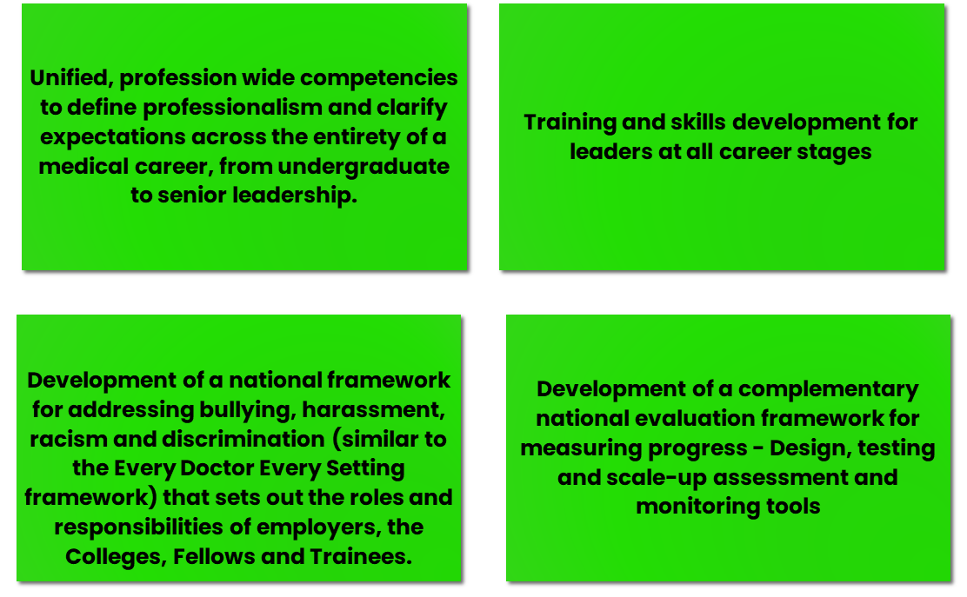

The Working groups will have representation from each of the Reference Groups, to act as both a conduit for communication/engagement, but also to ensure that working groups’ deliberations consider the diverse perspectives represented by the Reference Groups.

EXPRESS YOUR INTEREST
If you are interested in being a Member of a Reference Group, please email info@abetterculture.org.au and specify which Reference Group you would like to join, and whether you would be willing to Chair.

Kind regards,
Dr Jillann Farmer Helen Szoke
CEO, A Better Culture Chair, Advisory Board- A Better Culture

